Name : Tushar Pathak
Reg Num : 230905396
Roll Num : 6CSEB-B2

Week 10 : Databases – Part I

Q1)Assume a table “Institutes” with institute_id, name, and no_of_courses are the
fields. Create a web page that retrieves all the data from “Institutes” table
displays only Institute names in the list box.
Output :
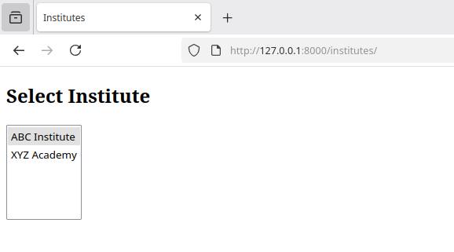
Webpage
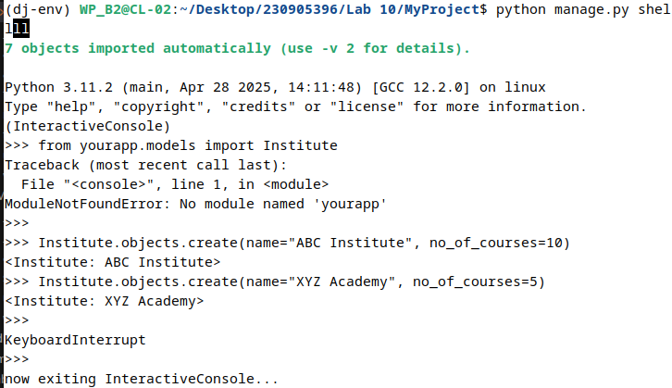
Adding Institute Datas

